**Case Study: Amul – The ₹80,000 Crore Giant That Refused to IPO**

**Dr Sharif Uddin Ahmed Rana**

**Introduction**

Amul, a ₹80,000 crore cooperative, exemplifies a business model that prioritizes collective ownership and rural empowerment over traditional profit-driven approaches. Founded in 1946, it transformed India's dairy sector, making the nation the largest producer of milk in the world. This case study explores Amul’s origins, its resistance to an IPO, and the broader implications of its success for cooperative and talent-driven economies.

**Origins: The Birth of a Revolution**

In pre-independence India, Gujarat’s dairy farmers were exploited by private contractors and middlemen, who controlled pricing and market access. This changed in 1946 when farmers, under the leadership of Sardar Vallabhbhai Patel, Tribhuvandas Patel, and support from Dr. Verghese Kurien, founded the Kaira District Cooperative Milk Producers’ Union.

This union laid the foundation for Amul, creating a cooperative system where farmers retained ownership and control over milk production and sales. The movement gained momentum during the White Revolution of the 1970s, led by Dr. Kurien, which transformed India from a milk-deficient country to the largest global producer.

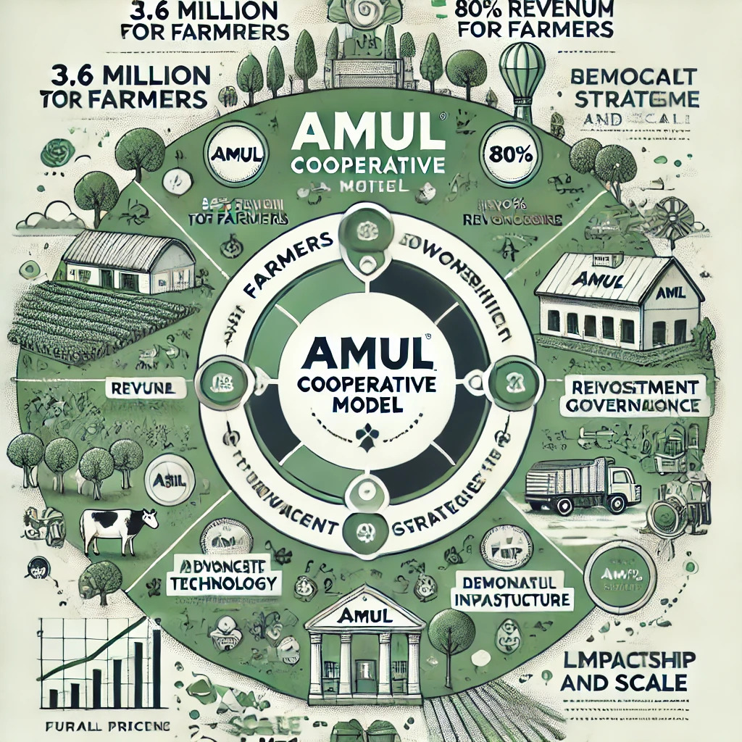

Amul operates under the Gujarat Cooperative Milk Marketing Federation (GCMMF), comprising 18 member unions and representing 3.6 million dairy farmers. The cooperative model ensures:

**Equitable Revenue Distribution:** 80% of revenues are returned to farmers, securing their livelihoods.

**Democratic Decision-Making:** Farmers actively participate in governance, maintaining control over strategic decisions.

**Focus on Welfare:** Profits are reinvested into initiatives like veterinary services, rural infrastructure, and education.

This ownership model aligns with Elinor Ostrom’s principles of collective action, proving that community-driven enterprises can sustainably manage resources and scale operations.

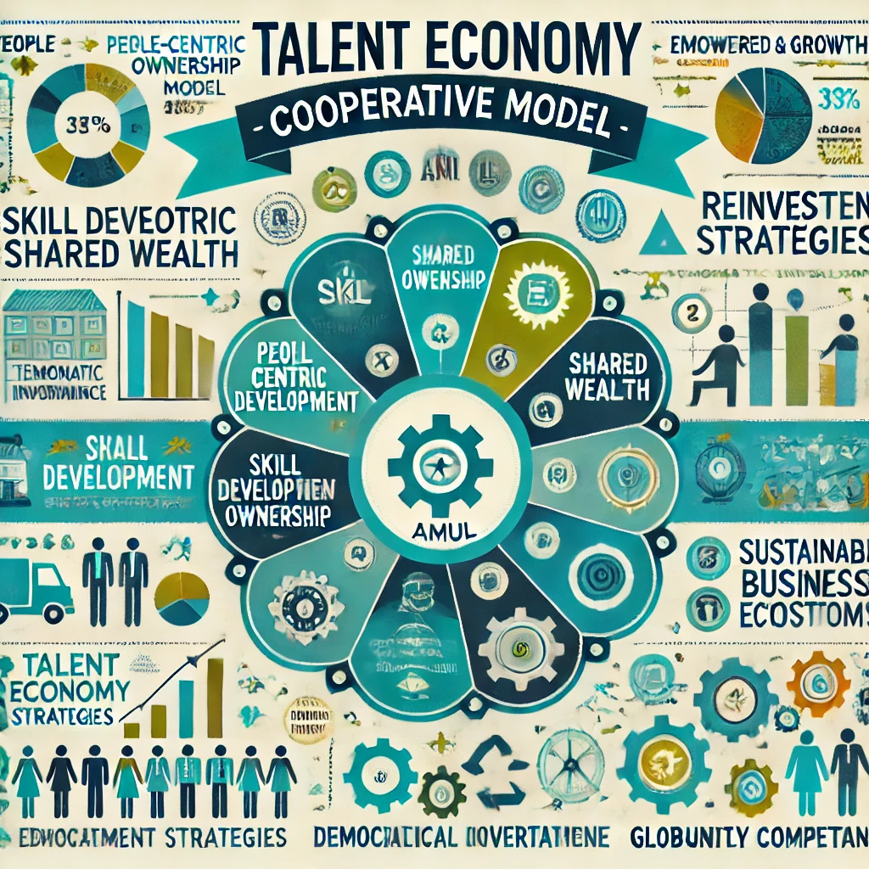

**Resistance to IPO: Preserving Values Over Valuation**

Unlike most large enterprises, Amul has resisted calls to go public. An Initial Public Offering (IPO) would introduce external shareholders, shifting focus from farmer welfare to stockholder profits. Amul’s decision is rooted in the belief that:

**Farmer Welfare Takes Precedence:** External shareholders could pressure management to prioritize dividends over fair farmer compensation.

**Reinvestment Over Dividends:** Profits are reinvested in technology, infrastructure, and price support systems.

**Mission Integrity:** Going public could dilute Amul’s cooperative mission and democratic governance structure.

**Impact:** A Catalyst for Rural Transformation

Amul’s cooperative model has delivered extraordinary social and economic impact:

**Economic Growth:** Amul contributes significantly to India’s GDP, with its supply chain employing millions across rural and urban areas.

**Rural Empowerment:** Farmers earn consistent, fair prices, reducing rural poverty.

Technology Adoption: Continuous investment in technology has modernized India’s dairy sector, enhancing productivity and quality.

The ripple effects of Amul’s success were pivotal in India’s White Revolution, which increased milk production from 20 million tonnes (1970) to 221 million tonnes (2021).

**Global Parallels: The Success of Cooperative Models**

Amul’s success resonates globally, with similar cooperative models demonstrating scalability and sustainability:

**Mondragon Corporation (Spain):** A worker-owned industrial cooperative with revenues exceeding €12 billion annually.

**Dairy Farmers of America (USA):** A farmer-owned cooperative managing 22% of the U.S. milk supply, ensuring fair prices and market stability.

These examples validate that collective ownership is not limited to local economies—it thrives on a global scale.

**Key Takeaways for the Talent Economy**

Amul’s cooperative model provides valuable lessons for businesses in the talent economy:

**People-Centric Ownership:** Empowering contributors (farmers, employees, or stakeholders) ensures long-term sustainability.

**Mission-Driven Growth:** Staying true to core values fosters resilience and community trust.

**Reinvestment for Impact:** Prioritizing innovation and infrastructure builds competitive advantage without compromising equity.

**Conclusion**

Amul’s refusal to IPO reflects its commitment to preserving the cooperative ethos that has driven its success. By prioritizing farmer welfare, reinvestment, and mission integrity, Amul has scaled into a global dairy powerhouse while staying true to its roots.

For the global talent economy, Amul offers a blueprint for businesses that aspire to balance scale, sustainability, and stakeholder empowerment.

As industries explore alternative models to maximize shared value, perhaps the future doesn’t need more IPOs—it needs more Amuls.

**References:**

Kurien, V. (2007). I Too Had a Dream. Roli Books.

GCMMF Annual Report (2022).

National Dairy Development Board (NDDB) Reports (2021).

Shukla, R. (2020). "Why Amul Will Never IPO." The Indian Express.

Cheney, G. (2002). Values at Work: Employee Participation Meets Market Pressure at Mondragon. Cornell University Press.

Kurien, V. (2007). I Too Had a Dream. Roli Books.

Shukla, R. (2019). “The Cooperative Revolution: Amul’s Journey.” Economic and Political Weekly, 54(32).

Ownership Model: The Cooperative Advantage

Cheney, G. (2002). Values at Work: Employee Participation Meets Market Pressure at Mondragon. Cornell University Press.

Dairy Farmers of America Annual Report (2023).

National Dairy Development Board (NDDB) Reports (2021).

Sharma, N. (2018). "Impact of the White Revolution." Journal of Rural Studies, 38(4).

Shukla, R. (2020). "Why Amul Will Never IPO." The Indian Express.

GCMMF Strategic Vision Document (2023).