|  |
| --- |
| For a better appreciation of my approach to cooperative management, see my website http://coopmanagement.ca. You can watch *7 videos* (15-20 minutes each), available on YouTube. These videos cover the following themes: 1st Identity crisis,2nd NPC and value congruence,3rd NPC and psychological ownership,4th NPC and loyalty,5th NPC and value co-creation, 6th Cooperative equilibrium and horizontal alignment (cohesions between members, between the association and the company, between the company and its market, 7th Cooperative equilibrium and vertical alignment (values and purpose alignment, the cooperative business model, the BSC balanced scorecard) and performance indicators, the cooperative network and the competitive environment. These videos are also available in French. |

Introduction [1]

Daniel Côté

Honorary Professor, HEC Montréal

Over the past two decades, companies have been (and still are) looking for new sources of efficiency, while most industries have reached stages of maturity and saturation. Companies invest in vast product ranges, but are less and less able to differentiate themselves...while the consumer buys (intelligently) at the best price. This helps explain why only a small percentage of the latter remain loyal, while the majority store around. Competition is therefore increasingly fierce. This makes it harder to develop customer retention.

In addition, internationally available information and communication systems, at virtually zero transaction costs, are leading to intensified interactions between customers, and between customers and companies. This encourages consumers to develop a new perception of themselves. They are becoming more active. These technological changes increase the degree of control, the volume of information and the power of consumers.

These different transformations, experienced on a market scale, are driving companies to seek new strategies for survival. They are also having to rethink the foundations of their business models, whether share capital companies or cooperatives.

As for cooperatives, they are undergoing not only the impact of market transformations, but also pressure on the relevance of their own identity. This additional pressure is experienced at both associative and corporate levels. It's important to remember that a cooperative is defined as an association of people who own a business. Many cooperatives thus follow a *denaturalizing trend*.

To overcome the challenges mentioned above, both in terms of market transformations and the cooperative organizational model itself, two theoretical models are developed: a **new cooperative paradigm** (figure 1), and a **cooperative equilibrium model** (figure 2). The combination of these two models highlights the potential competitive advantage of the cooperative mode of organization in response to the aforementioned transformations.

*A new cooperative paradigm* (NPC)

Webster's (dictionary) defines a paradigm shift as "*a significant change that occurs when the usual way of thinking or doing something is replaced by a new and different way. This discovery will lead to a paradigm shift in our understanding of evolution.*"

The basic idea behind this NPC is to seek out the advantages inherent in the cooperative organization mode when faced with current and future challenges, compared with other organization modes. The challenges briefly mentioned above are forcing companies to look for new strategies. In this book, the strategies selected are: (1) value congruence, (2) psychological ownership, (3) loyalty and commitment, and (4) value co-creation. For each of these strategies, three key questions are addressed. Firstly, what are the competitive advantages associated with them, irrespective of the type of organization? Secondly, how do the foundations of the cooperative difference converge with the essential parameters to be mastered to design, implement and operationalize these strategies? Finally, what are the sustainable competitive advantages unique to the cooperative mode of organization in relation to these same strategies?

Figure 1 - The new cooperative paradigm

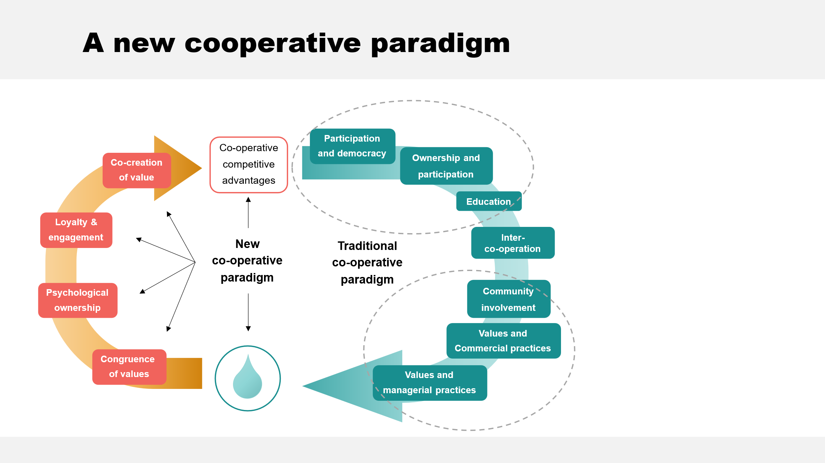

Value congruence and self-improvement

Given the great importance of values in appreciating the cooperative difference, it is essential to understand their strategic importance in greater depth. To assess the strategic importance of cooperative values, Schwartz's taxonomy of values is used[2] . This taxonomy demonstrates the strong convergence between self-improvement (values of benevolence and universalism) and cooperative values. Moreover, the universal nature of Schwartz's taxonomy demonstrates the importance of different value profiles. Of the 4 profiles investigated (self-improvement, assertiveness, openness to change and conservatism), the self-improvement profile is the most important, while assertiveness ranks 3e . The new perspective on cooperative values seen through the lens of Schwartz's taxonomy therefore recognizes their importance on a global scale.

Beyond the universal preponderance of cooperative values, their impact on corporate performance needs to be explored. To this end, the concept of **value congruence** (corporate and employee values) is highly relevant. There are several key observations to be made in this regard. Such congruence (adequacy) is known to increase employee satisfaction and retention...and boost organizational performance.

Research on congruence does not, however, specify which value profile(s) to favor. Human resources (HR) research has made some important observations in this area. Asking the question of cooperative values in relation to corporate performance offers few answers, as very little (...) research has been done in this area. But asking the same question using Schwartz's taxonomy, particularly in relation to self-improvement (strong convergence with cooperative values), provides answers to this essential question. The highly strategic nature and (potential) impact on the cooperative's performance can be demonstrated.

HR research supports the hypothesis that *self-improvement* values are correlated with affective commitment (of employees to the company), discretionary, prosocial and ethical behavior. Reviewed from this new perspective (new paradigm), the findings relating to value congruence and self-improvement values lead to a key hypothesis: cooperative values can be seen as sources of competitive advantage.

Psychological property

The 2e strategy adopted in the conceptualization of this new cooperative paradigm concerns "**psychological ownership**". Over the past twenty years, this concept has gained ground in marketing as an explanatory factor in consumer behavior. The added value (associated with this sense of psychological ownership) perceived by the consumer accentuates customer retention and referrals, reinforces resistance to competitors' offers, and so on. It is therefore important to investigate the relationship between the foundations of psychological ownership and cooperative distinction.

At the root of such a feeling are motivations: affectance (anticipating a degree of control over one's environment), identification (who am I, sense of organization), having a place (privileged space to structure one's daily life), all key intrinsic motives, inciting its emergence. A 2e key element to consider is the itineraries facilitating the activation of these intrinsic motivations. Three routes are identified: accentuating the degree of control over the object towards which the consumer can develop a sense of psychological ownership (this object may be the organization), intimate knowledge of the object and the consumer's investment in the object (time, ideas, money...). Also to be considered are the attributes of target objects: attractiveness, accessibility, receptivity and manipulability. The strategy leading to the development of a sense of psychological ownership must therefore integrate these three key dimensions. Psychological ownership can be developed both individually and collectively.

The cooperative mode of organization offers an ideal framework for actualizing and operationalizing such a strategy. In the first place, the motives mentioned are all highly relevant and at the root of the member's creation and/or adhesion to the cooperative. In terms of itineraries, all 3 are directly in line with cooperative principles. The degree of control over the object is structurally integrated into the design of cooperative ownership (4 distinctive rules...democratic power, link of use, sharing of surpluses in proportion to the member's activities with his cooperative, and collective reserve). These 4 rules give members (collectively) a high degree of control over their cooperative. Intimate knowledge of the object can be achieved through relevant associative practices (education, information and consultation). Finally, the member's investment in his cooperative is facilitated by a triple participation in capital, power and results. The association-business duality at the heart of the cooperative distinction illustrates how the cooperative structure facilitates the implementation of these three routes. The cooperative can thus take advantage of the unique design characteristic of its mode of ownership to develop such a feeling, adding value and favorably impacting member loyalty to itself.

Loyalty management

The 3e strategy exploited aims to strengthen **loyalty management** (member loyalty to the cooperative). Such a strategy must be based on a philosophy, principles and values that the cooperative intrinsically embodies. The principles of ethics and integrity, transparency and proximity to the customer, genuine interest in the customer... these are all key elements at the heart of the cooperative identity. In terms of competence, operational excellence is essential, but so is operational benevolence... which brings us back to the values described above.

Loyalty management also requires us to distinguish between satisfaction and loyalty. Whereas from the point of view of satisfaction, the customer is often in an ambivalent situation, from the point of view of loyalty, the customer must first be seen as a person, then as a consumer. Three fundamental needs must be addressed, namely security (organizing and controlling what makes him feel safe), justice (being treated fairly) and self-esteem (feeling useful, having value, feeling in control and having a sense of competence). These three fundamental needs can be addressed much more effectively in a cooperative when its fundamental distinction is taken into account, i.e. its values and principles, its duality (owner-user, association-business), its ideological underpinnings (primacy of use over capital, a higher grouping of humans and economic considerations, a concern for greater equity, an ideal of social justice). In addition to these key factors, there is a greater potential for legitimacy and social capital. When understood and integrated into the cooperative business model, these factors support the hypothesis of a sustainable competitive advantage for this mode of organization in loyalty management.

Value co-creation

The **strategy of value co-creation** is also emerging as an important competitive lever, pushing back the boundaries of the company in its quest for new sources of efficiency. Technological changes, and the Web in particular, have given consumers more power over the value-creation process, redefining the roles customers are called upon to play in innovation and value creation. Beyond recommending and promoting products and services, customers can become idea generators, co-creators and advocates of the company. The co-creation strategy is based on two key transformations: the democratization of the value creation process, and the decentralization of this process to experiential co-creation platforms. Such a strategy requires customer commitment, which is why it's important to understand the sources of motivation behind such behavior, and the expected benefits (acquisition of information and a better understanding of their environment, social and relational ties, enhanced credibility and a greater sense of self-efficacy, emotional benefits).

The practices that underpin this strategy require interactivity, deep commitment, skill and a mutual willingness to collaborate. The resulting dialogue is also based on access to information, transparency and understanding of risks.

On the other hand, there are many barriers to co-creation, including issues of exploitation (feeling exploited, opportunism), governance (managing a dynamic group of consumers), the need for sufficient cohesion between stakeholders, mutual trust and learning efforts...These barriers need to be overcome to encourage customers to engage (voluntarily) in this co-creation process.

In terms of all these necessary conditions, the cooperative organizational mode has a strong advantage. The introduction of an appropriate management framework, the cooperative equilibrium (figure 2), will support this hypothesis and the idea that the cooperative benefits from competitive advantages in building on this strategic approach of innovative co-creation. It's important to remember that the very existence of the cooperative is an act of co-creation. This emerging strategy (for the share-capital company) is therefore at the heart of the cooperative logic of action.

*A cooperative balance*

The second key idea of this book introduces the concept of cooperative equilibrium (figure 2). For the logic of action specific to the cooperative management style to be expressed on a day-to-day basis, cooperative values, principles and rules must be articulated within an appropriate management framework. This is what the cooperative equilibrium model proposes.

Figure 2 - Managing cooperative equilibrium

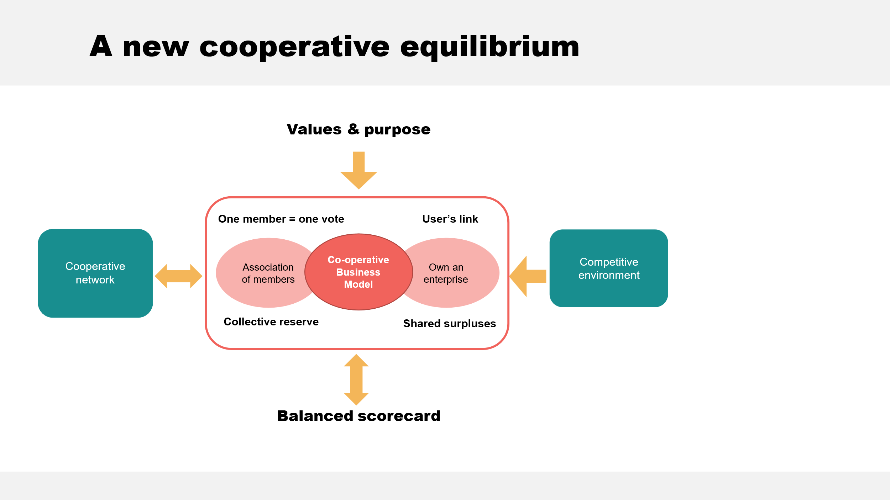

Horizontal alignment

This model of cooperative equilibrium (figure 2) is first built on distinct rules (democracy, link of use, sharing of surpluses in proportion to member/cooperative activities and collective reserve). Integrating these rules into a cooperative management framework is essential because they are at the heart of its distinction. They will have a key impact on the direction and control of the business by the members' association. These rules are expressed in a duality (owner-user, association-company, collective-individual and social-economic) based on three levels of cohesion (between members, between members and *their* company, between the company and its market). From these distinct rules and dual structure emerges a horizontal alignment at the basis of a cooperative business logic...

This horizontal alignment is also a strategic lever at the heart of the strategies adopted by the new cooperative paradigm (figure 1). To convince ourselves of this, we need only recall the importance of congruent values (consumer and corporate) as a factor of trust, the motives and itineraries at the root of an individual psychological sense of ownership, and the cohesion required in terms of values and purpose between consumers for such a collective feeling to manifest itself. Also the key role of customer engagement at the heart of a value co-creation strategy. These are all factors that can be managed more effectively when such horizontal alignment is understood and (structurally) operationalized. This is what the cooperative equilibrium model invites us to do, but what the share-capital company struggles to achieve because such organizational dynamics are in no way part of its logic of action.

Vertical alignment

Beyond the challenges specific to the three levels of cohesion, an adapted cooperative management framework must ensure alignment between the organization's values and purpose, the foundations of its business model and its key performance indicators. The resulting vertical alignment must be implemented within the company, unlike the horizontal alignment designed in relation to the association of members.

Values and purpose reflect an ideological core (...) that is intended to inspire and guide. This ideological core must be authentic, non-negotiable, natural, and define the timeless character of the organization. The integration of cooperative values within the company must take place via the employees themselves. Let's briefly recall the previous findings concerning the values congruence strategy. Both value congruence and cooperative values (seen from the angle of Schwartz's taxonomy...surpassing oneself) will have a positive and significant impact on company performance. Such an alignment of values within the (cooperative) company is therefore required.

The 2e component of this vertical alignment involves the conception and design of a business model. An effective business model requires a cycle of iteration and configurational adjustment of the key constituent elements, namely the strategic core, the strategic resources, the customer interface and the value creation network. Configuration can be defined as the degree to which key elements are orchestrated and connected by a theme such as cooperative identity. The aim of a configuration is to create harmony, consonance and fit between the elements.

Thinking in terms of business models (rather than products) significantly increases the potential scope for innovation. While the NPC strategies can be integrated into the 4 pillars of the business model, this allows the latter to be conceived as a radical innovation that brings differentiation, all based on the foundations of the cooperative identity.

In management, it's said that "*what gets managed gets measured...and what gets measured gets managed*". To ensure the construction and development of a cooperative balance, the question of the measurement indicators to be taken into consideration is fundamental. To this end, a balanced scorecard (BSC) must be integrated into this cooperative equilibrium (figure 2). The BSC is a management tool that integrates mission and strategy, implementation issues and the four key (basic) perspectives identified: customer perspective, financial perspective, internal processes, and learning and growth. To ensure that the organization, its methods and orientation are aligned with a goal focused on member service, the indicators selected must reinforce the alignment of the key components of the BSC. When integrated into a cooperative management model, the BSC is therefore an essential tool for *identifying and measuring what needs to be managed...and managing what will be measured*. The unique action logic of the cooperative model must be reflected in the BSC measurement tool.

The environment and cooperative balance

The cooperative equilibrium model also introduces the environmental aspects in which cooperatives evolve. Competitive forces and evolutionary factors are bound to have a major impact on the management of the cooperative equilibrium. Like share-capital companies, cooperatives compete in the marketplace, and must ensure that they know and master the key success factors that drive them. At the heart of the third level of cohesion identified above (horizontal alignment) was the importance of strategic *fit*, which is based on the adequacy of threshold capabilities and capabilities enabling the development of competitive advantages. These capabilities must be linked to the key success factors specific to the markets in which cooperatives operate. The strategic diagnosis thus aims to identify the room for manoeuvre available to cooperatives to build a distinct business model. Where there is little (or no) room for maneuver, the cooperative identity will have little impact on "adding value for stakeholders", hence the importance of revisiting the potential competitive advantages inherent in the cooperative mode of organization.

Another key aspect of cooperatives is that they are part of an international network and movement. The vast majority of cooperatives are (or will be) members of a cooperative federation. The influence of these networks and structures will have a strategic impact on cooperatives that must be taken into account to understand how the cooperative equilibrium is (can be) constructed. The federation has a key role to play, both in strengthening the competitive advantages of 1e level cooperatives, but also in ensuring that this is done in a way that reinforces the cooperative equilibrium (and the NPC).

*A malaise of identity*

The final key idea introduced in this book concerns the *denaturalizing tendency* observed among many cooperatives, leading to an identity malaise briefly mentioned earlier.

To better understand this trend, the proposed model is based on two axes: the intensity of cooperative rules and the intensity of market rules. This model, structured in four quadrants, traces a path, a trajectory, followed by cooperatives (Figure 3). The assumption made here is that cooperatives emerge in the 1e quadrant.

Several structural changes influence cooperative rules (vertical axis) in relation to their business orientations and practices. The initial motives behind the creation of cooperatives (linked to market failures...monopoly, etc.), individualization, membership size (from which free-rider behavior emerges), and the loss of meaning associated with cooperative ownership...are all factors that weaken the intensity of cooperative rules, and the influence they will exert on trade-offs within the company.

In terms of the intensity of market rules, the cooperative enterprise is influenced by what sociologists call *isomorphism* (a constraining process that forces an organizational form, such as the cooperative, to resemble other organizational forms, such as the share-capital enterprise), fuelled by *economic competition*, but also by institutional issues such as *coercion* (regulatory, political and legitimization pressures), *mimicry* and the search for standardized responses to environmental uncertainties, *normative* and acceptance of a certain approach to the organization. These sources of competitive and institutional pressure are compounded by the lack of training in cooperative management offered to managers (particularly in business schools), which further reinforces the propensity of cooperative organizations to base their actions, orientation and methods on those of the share-capital enterprise. Seen in this light, it's hardly surprising that cooperative managers are finding it increasingly difficult to recognize and assert their cooperative distinctiveness, hence this observation of "identity malaise". On the other hand, revisiting cooperative foundations in relation to market transformations (NPC) enables us to formulate a 2e fundamental hypothesis: the potential for competitive advantage inherent in the cooperative mode of organization paves the way for the 4e quadrant. Otherwise, the pressure to demutualize will only increase on existing cooperatives.

Figure 3 - From identity malaise to the new cooperative paradigm (NPC)

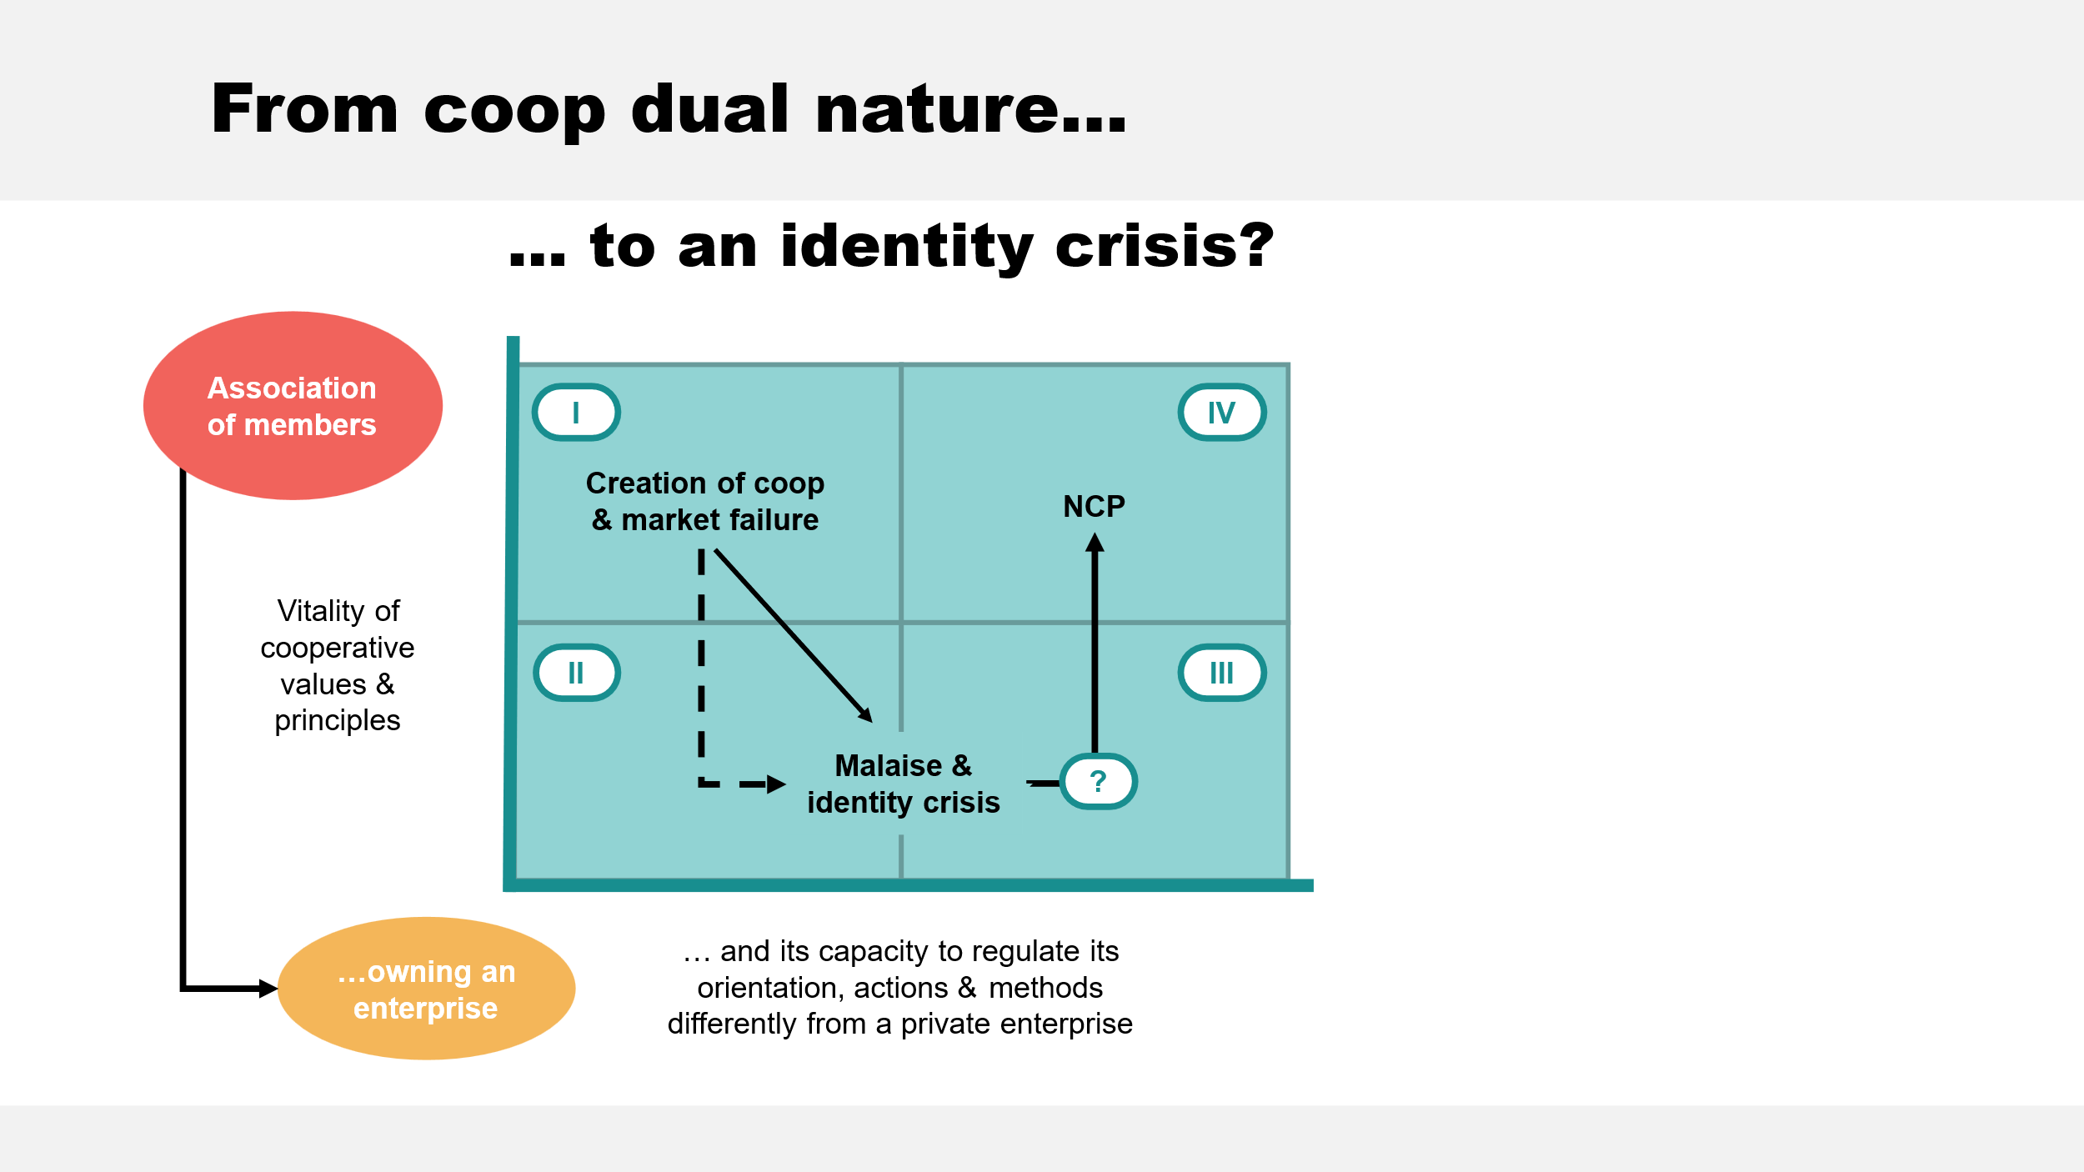

The three models introduced (Figures 1, 2, 3) form the first part of this book. The second part offers a practical perspective, and includes several case studies of cooperative management. These cases were written over the last 20 years. These cases illustrate the different facets and components of the three ideas on which the cooperative management approach offered here is based.

Cooperatives

*Agropur* was at the heart of the conceptualization of the cooperative equilibrium model (figure 2). This case illustrates the model in its entirety, while the associative and entrepreneurial aspects are highlighted. In fact, there are three cases (Agropur A, B and C), each written at a different period in the cooperative's history. The first case illustrates the overall model, association & enterprise. The second case deals with the quest for cohesion (between members and the cooperative) in the late 90s, and the consultation process undertaken to achieve it. The third case also illustrates the challenges of cohesion, but this time between the enterprise and market conditions.

To fully understand the dynamics of the cooperative equilibrium model, we also need to focus on the issues and challenges specific to the ideological core (values and purpose) and the business model. Several cases are presented to illustrate these key components of the cooperative equilibrium. The cases of *Seward (A, B), Weaver Street Market* and *Vancity* were written for this purpose. The first two are food cooperatives in the USA, while the third is a credit union in Vancouver, Canada. These cases illustrate how a cooperative can build a different, competitive business model that creates value for its members and their communities.

To address BSC in the context of cooperative equilibrium, the case of *Coop HEC*, a university cooperative (HEC Montréal), is selected. This community cooperative brings together students and employees of this *business school* (including professors). The case presents strategic issues (formulation and implementation) as well as member, financial, business process and human resources perspectives. The "balanced" approach demonstrates the integration of the four perspectives at the heart of the BSC in a cooperative management context, facilitating the adjustment of actions, methods and orientation in pursuit of an objective focused on optimizing member service...while ensuring the company's sustainability.

Finally, still in connection with the cooperative equilibrium model, a case is selected that deals with leadership issues in relation to cooperative identity. The case concerns *The Co-operators*, a Canadian insurance cooperative.

To illustrate certain key aspects of NPC, three cases are published: *St-Roch-de-L'Achigan* (a Desjardins caisse located in Quebec), *Affinity Plus Credit Union* and *Educators Credit Union*, two American financial cooperatives. These three cases address the issues of values-based mobilization, psychological ownership, loyalty and commitment management, as well as democratization and value co-creation. At this stage, these emerging models are only treated in an experimental phase. An exception to be noted with loyalty management issues and challenges, however, is that the case of *the caisse de St-Roch de L'Achigan* is the result of action research that extended over a 10-year period (1999-2008).

The identity malaise model (figure 3) is illustrated with examples in chapter 6e . These examples were developed in the late 90s as part of an international research project. On this occasion, several case studies of European and Canadian cooperatives were written. While reflecting the context of the turn of the century, these cases illustrate very well the issues at the heart of identity malaise experienced on an international scale.

1. Cooperative management, theory and practice - From specificity to competitive advantage, emergence of a new paradigm. JFD 2022, pp. 9-23.
2. The universal taxonomy of values developed by Schwartz takes the form of a continuum of linked motivations that give rise to a circular structure. Ten values are identified (simplified model). These 10 values can be grouped into 4 dimensions organized along 2 axes. A 1e axis...openness to change and conservatism. A 2e axis...self-improvement and assertiveness. As will be shown in 1e chapter, the values of self-improvement (benevolence and universalism) group together cooperative values, while the values of self-assertion (accumulation of wealth and power) correspond more closely to the value profile of the share-capital company.